|  |  |
| --- | --- |
| **CASE CONFERENCING FOR BETTER PATIENT CARE** | |
|  | **WHAT IS A CASE CONFERENCE?** |
| A case conference is a meeting or discussion held to plan and monitor a patient’s care to ensure their needs are met through a collaborative and coordinated approach. This typically would include a GP, the patient and two additional health service providers.  **It is claimable through MBS items 735, 739, 743 (GP organised) or 747, 750 (hospital organised and GP participation).** |
|  | **WHO IS A CASE CONFERENCE FOR?** |
| A case conference can be used for patients with a chronic medical condition and/or complex care needs. |
|  | **WHO PARTICIPATES IN A CASE CONFERENCE?** |
| The case conferencing team must include a GP and at least two other health or community care providers, one of whom can be another medical practitioner. Each team member should provide a different kind of care or service to the patient.    Examples of persons who may be included in a multidisciplinary care team are:   * Allied health professionals; * Home and community service providers; * Care organisers such as education providers, “meals on wheels” providers, personal care workers and probation officers. |
|  | **STEP-BY-STEP GUIDE** |
|  | The HealthCare to Community (HC2C) team will arrange the case conference with your practice reception staff and confirm in writing. It is the GP’s responsibility to ensure the patient is aware of their practice’s policy for billing case conferences. |
|  | When the patient arrives at your practice for their scheduled appointment **call 0434 601 845** and put your phone on speaker so the patient (and their support person/s) can participate. |
|  | During the case conference, the HC2C team will handover relevant information and we will discuss next steps. |
|  | Following the case conference, the HC2C team provide a summary of the case conference with action items to the GP and patient. |
|  | In the case of changes to the case conference or if an issue arises, please contact the HC2C team on **0434 601 845**. |

***AFTER THE CASE CONFERENCE…***

Please provide feedback via the QR code or via the link

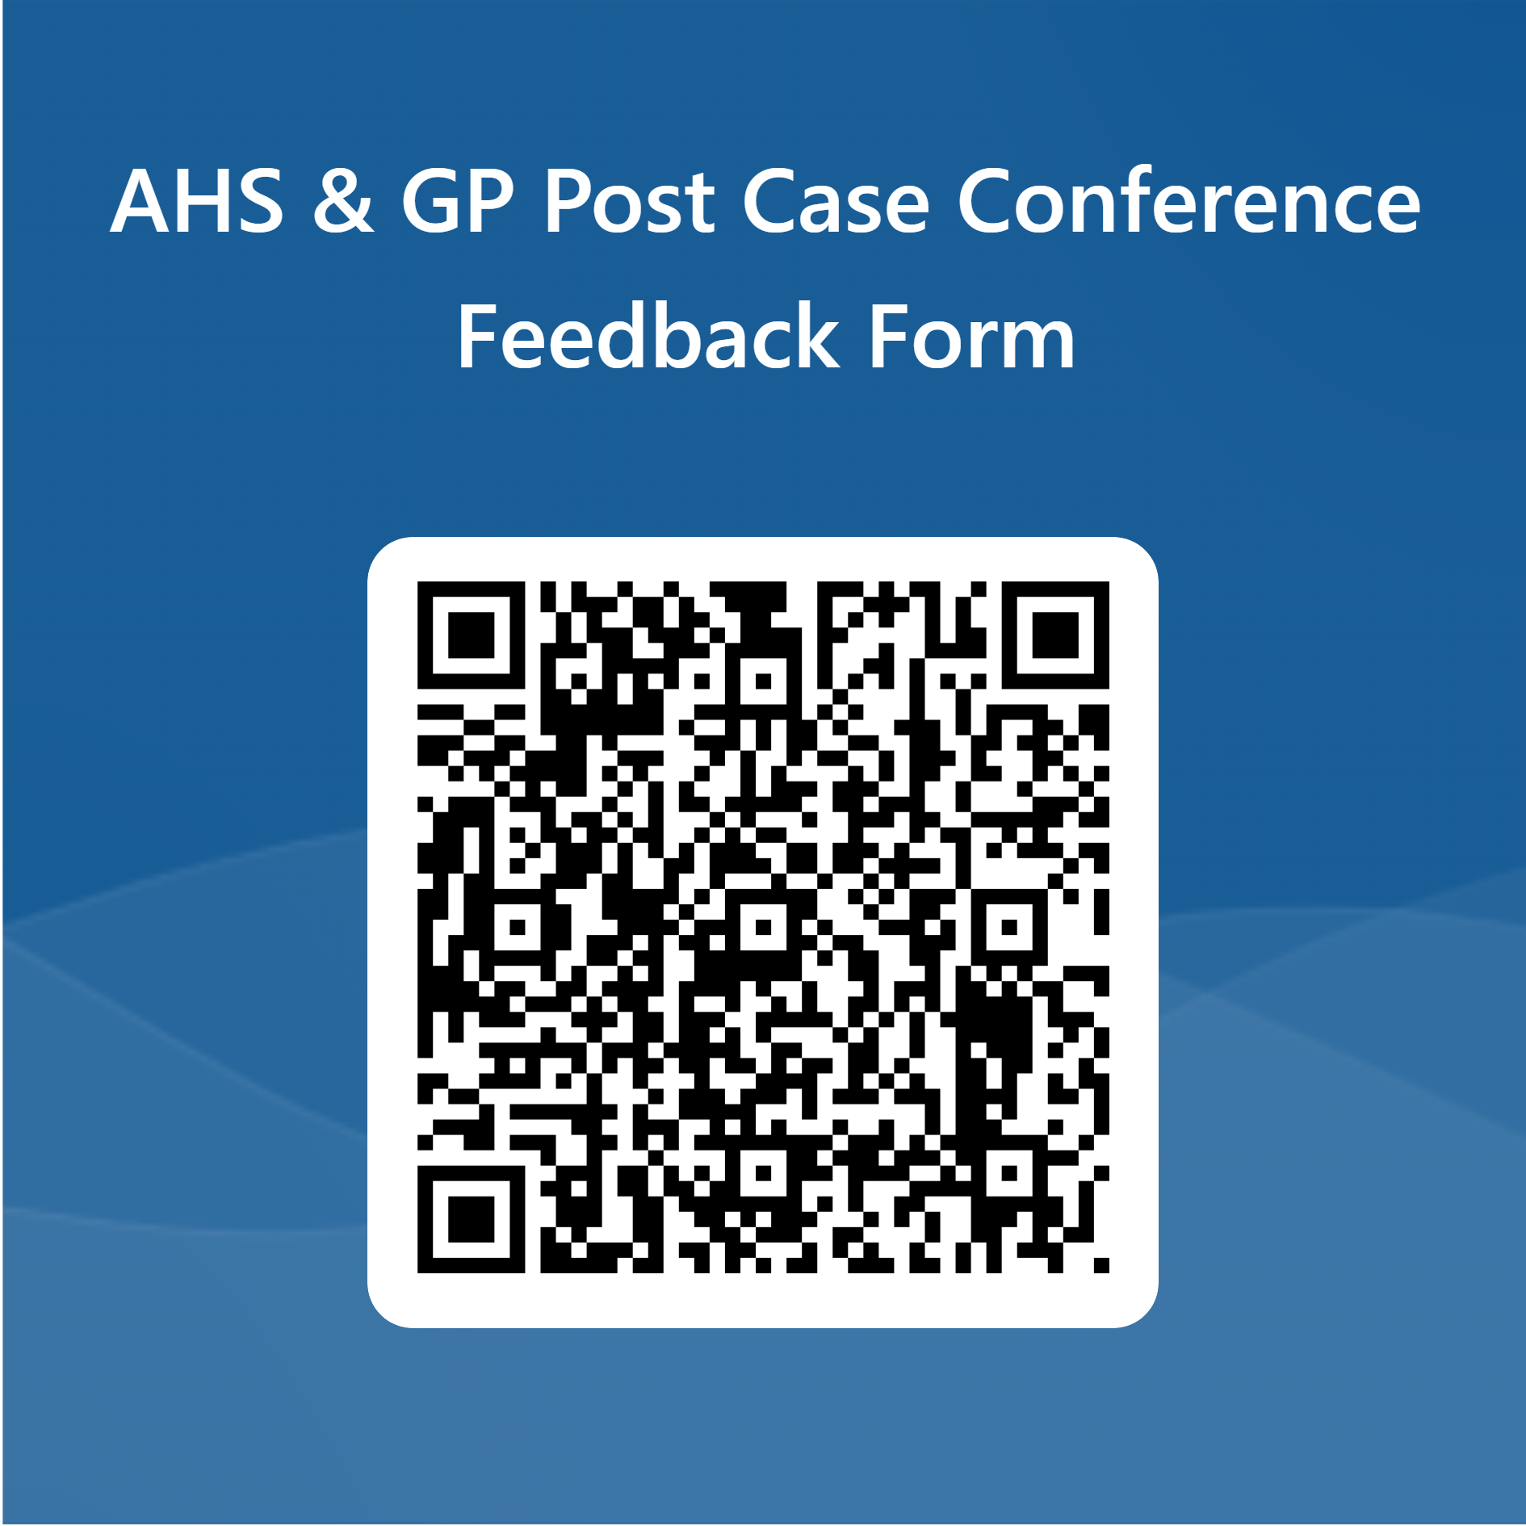

***WOULD YOU LIKE TO INITIATE A CASE CONFERENCE FOR ANOTHER PATIENT?***

To initiate another case conference or use our information sharing service, please use the QR code below or via the link:

<https://forms.office.com/Pages/ResponsePage.aspx?id=ub4mXTDXQ0OiUdFwyoY3fEFIIAloUUZOuc5Eb1wYfsZUM0FYQlFPVEk3TVFWRE5HVUVVQzBEWUtWTiQlQCN0PWcu>

